**FPT UNIVERSITY**

**\*\*\***

**Student Grading Management Sub-System**

DBI202

Student ID: HE160674

Student Name: Nguyễn Huy Minh

Class: SE1647

Lecture: Ngô Tùng Sơn

1. A brief description of the database
2. Assumptions:

+ How many subjects can a student study in 1 semester?

+ Can students study 2 majors at the same time?

+ Is the format of scores for all subjects the same?

+ …

1. Hope the database can:

+ Caculate AVG of each subject

+ Display scoreboard of each student

+ …

3. Design the database

This database included 11 tables

Student

* 7 students
* 7 records

Subject

* 5 subjects
* 5 record2

Lecture

* 5 lectures
* 5 records

Group

* 2 groups
* 2 records

Assessment

* 39 records

Group_Lecture

* 5 records

Group_Student

* 7 records

Group_ Subject

* 5 records

Lecture_Subject

* 5 records

Subject_Semester

* 5 records

Result Of Semester (Student_Assessment)

* 138 records

1. An ERD (Entity Relationship Diagram)

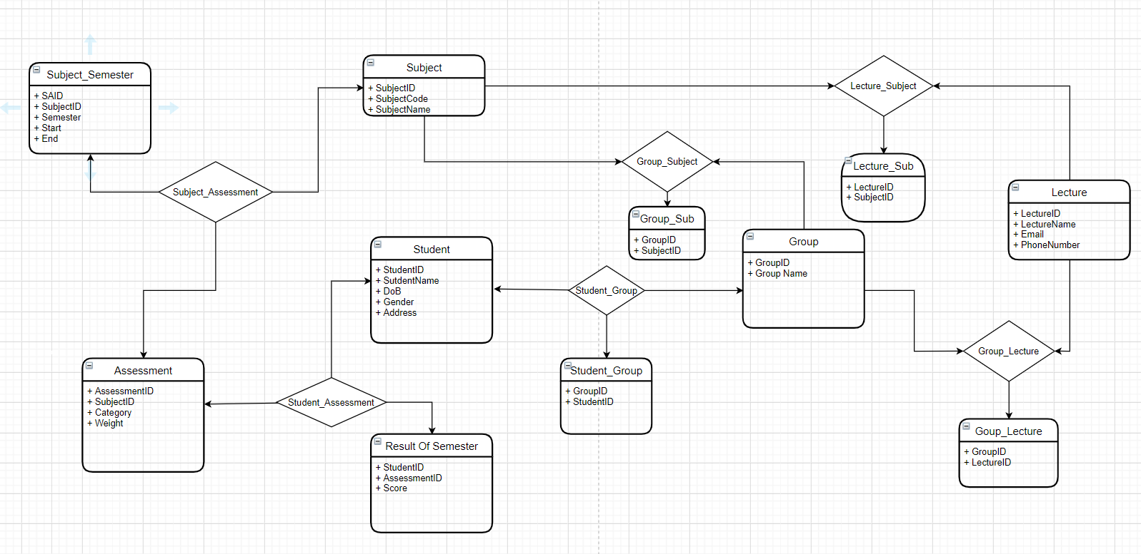

1. The relational schema derived from the ERD that is at least in 3NF

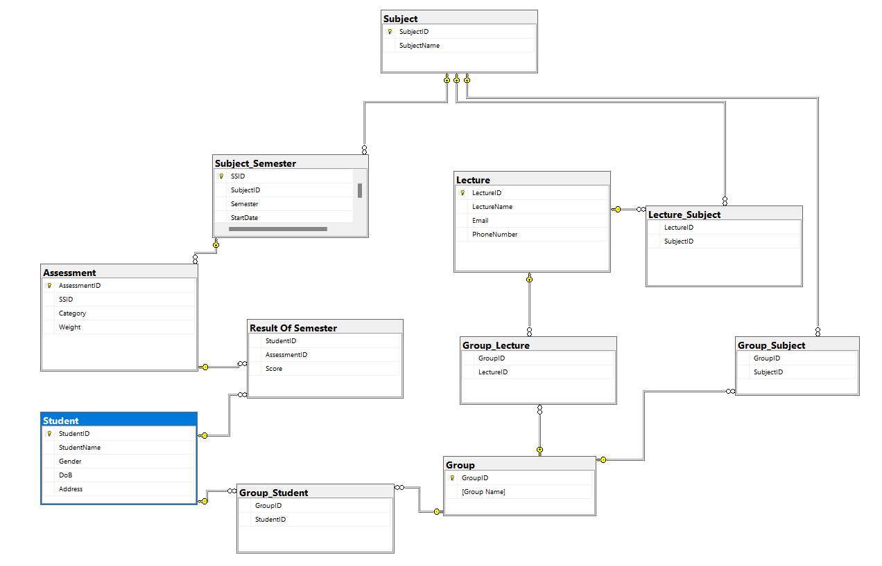

1. The set of database statements used to create the tables used in your database.

CREATE TABLE Student (

StudentID varchar(10) PRIMARY KEY,

StudentName nvarchar(50),

Gender BIT,

DoB date,

Address nvarchar(30)

)

CREATE TABLE Subject (

SubjectID varchar(10) PRIMARY KEY,

SubjectName nvarchar(30),

)

CREATE TABLE Subject_Semester (

SSID varchar(20) PRIMARY KEY,

SubjectID varchar(10) FOREIGN KEY REFERENCES [Subject](SubjectID),

Semester varchar(20),

StartDate DATE,

EndDate DATE

)

CREATE TABLE Assessment(

AssessmentID varchar(20) PRIMARY KEY,

SSID varchar(20) FOREIGN KEY REFERENCES [Subject_Semester](SSID),

[Category] nvarchar(150),

[Weight] float,

)

CREATE TABLE Lecture (

LectureID int PRIMARY KEY,

LectureName nvarchar(30) ,

Email varchar(30) ,

PhoneNumber varchar(10)

)

CREATE TABLE [Group] (

GroupID int PRIMARY KEY,

[Group Name] varchar(20)

)

CREATE TABLE [Group_Student] (

GroupID int FOREIGN KEY REFERENCES [Group](GroupID),

StudentID varchar(10) FOREIGN KEY REFERENCES [Student] (StudentID)

)

CREATE TABLE [Group_Lecture] (

GroupID int FOREIGN KEY REFERENCES [Group](GroupID),

LectureID int FOREIGN KEY REFERENCES [Lecture] (LectureID)

)

CREATE TABLE [Group_Subject](

GroupID int FOREIGN KEY REFERENCES [Group](GroupID),

SubjectID varchar(10) FOREIGN KEY REFERENCES [Subject](SubjectID)

)

CREATE TABLE [Lecture_Subject] (

LectureID int FOREIGN KEY REFERENCES [Lecture] (LectureID),

SubjectID varchar(10) FOREIGN KEY REFERENCES [Subject](SubjectID)

)

CREATE TABLE [Result Of Semester] (

StudentID varchar(10) FOREIGN KEY REFERENCES [Student] (StudentID),

AssessmentID varchar(20) FOREIGN KEY REFERENCES Assessment (AssessmentID),

[Score] float

1. Queries that demonstrate the usefulness of the database

1. A query that uses ORDER BY

// Sort student list by date of birth (YEAR)

SELECT * FROM Student s

ORDER BY Year(s.dob)

// Result:

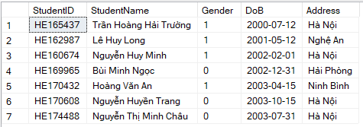

2. A query that uses INNER JOINS

// Check Group, Lecture and Subject

Example: Student whose StudentID is HE160674 check his Class, Lecture and Subject

SELECT s.StudentID, s.StudentName, g.[Group Name], l.LectureName, sub.SubjectName

FROM Student s INNER JOIN [Group_Student] gs ON s.StudentID = gs.StudentID

INNER JOIN [GROUP] g ON gs.GroupID = g.GroupID

INNER JOIN [Group_Lecture] gl ON g.GroupID = gl.GroupID

INNER JOIN [Lecture] l ON gl.LectureID = l.LectureID

INNER JOIN [Lecture_Subject] ls ON l.LectureID = ls.LectureID

INNER JOIN [Subject] sub ON ls.SubjectID = sub.SubjectID

WHERE s.StudentID = 'HE160674';

//Result:

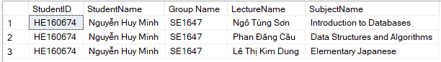

3. A query that uses aggregate functions

// Student can check the AVG of each subject

Example: Student whose StudentID is HE160674 check his AVG of each subject

SELECT rs.StudentID, a.SSID, SUM(rs.Score * a.[Weight]) AS [AVG]

FROM Assessment a INNER JOIN [Result Of Semester] rs ON a.AssessmentID = rs.AssessmentID

WHERE rs.StudentID = 'HE160674'

GROUP BY rs.StudentID, a.SSID

ORDER BY [AVG]

// Result:

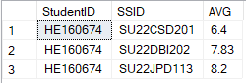

4 A query check the scoreboard of each subject

//Example: HE160674 check scoreboard of CSD201

SELECT a.Category AS [GRADE ITEM], a.Weight AS [WEIGHT], rs.Score AS [VALUE]

FROM [Result Of Semester] rs JOIN Assessment a ON rs.AssessmentID = a.AssessmentID

WHERE rs.StudentID = 'HE160674' AND a.SSID = 'SU22CSD201'

//Result:

